Short article on Bath’s CAZ:

Get ready for Bath’s Clean Air Zone

Bath’s clean air zone is set to launch on Monday 15 March 2021 to urgently improve air quality in the city. It means that most higher emission vehicles – except private cars and motorbikes – will be charged to drive in the city centre.

A higher emission vehicle is a Pre Euro 6/VI diesel vehicle (Euro 1 to 5/V or earlier) or Pre Euro 4 petrol vehicle (Euro 1 to 3 or earlier).

You can now check whether your vehicle will be charged using your vehicle registration number at GOV.UK’s Central Clean Air Zone Service: www.gov.uk/cleanairzone.

If charges apply, please refer to Bath & North East Somerset’s website for a list of local exemptions and whether you might be eligible for financial support to upgrade or replace a non-compliant vehicle or fleet of vehicles.

While private cars are not charged in Bath’s zone, the Council is asking everyone to consider whether they need to use their vehicle, especially for short trips where walking, cycling or taking public transport is possible. We all have a part to play in improving air quality.

To find out more, go to www.bathnes.gov.uk/BathCAZ

Need a quick overview? Watch the video

<END OF SHORT ARTICLE>

Optional accompanying social media posts:

Bath’s Clean Air Zone will launch on Monday 15 March 2021. Private cars will not be charged, but most other higher emission vehicles will. You can check your vehicle registration online to see if you’ll be charged. Go to www.bathnes.gov.uk/BathCAZ

Cleaner air is coming to Bath. From 15 March 2021 most higher emission vehicles will be charged to drive in the city centre. Private cars will not be charged. You can check your vehicle registration online to see if you’ll be charged. Go to www.bathnes.gov.uk/BathCAZ

You can also insert/feature the video in the post by downloading it from the vimeo link below.
Use password: caz
https://vimeo.com/466147110
See also a map of the zone below:

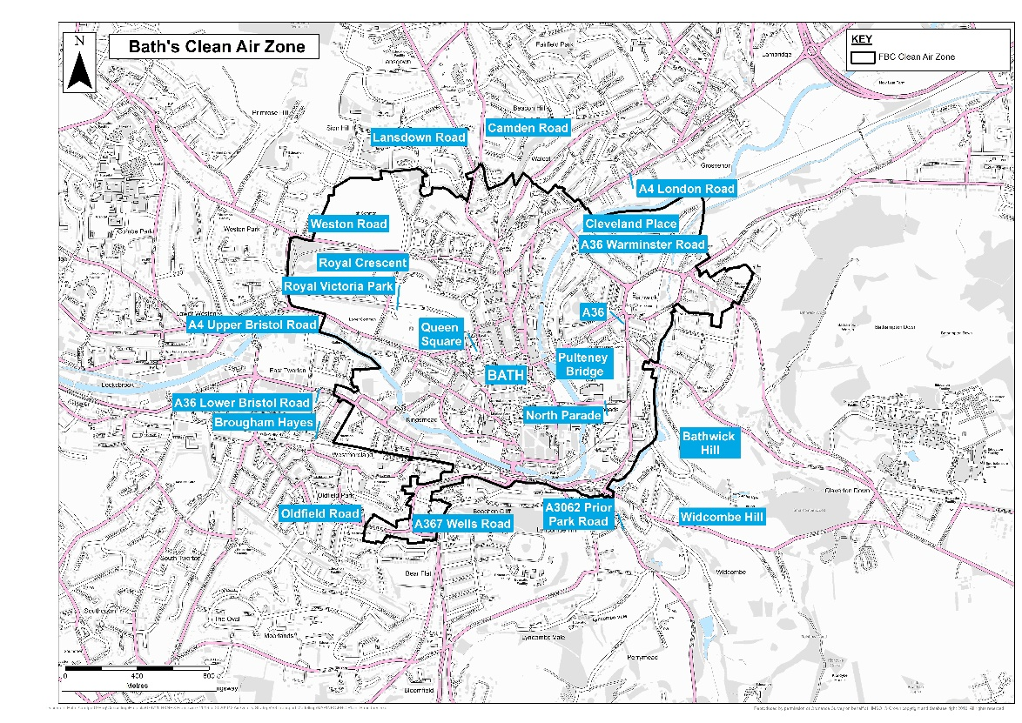

Above is a map of Bath showing the Clean Air Zone boundary in black.

If you have any questions about using the material supplied here, please email jan_fletcher@bathnes.gov.uk

